**Semester: V (2023-24) Subject:** Communication Networks

**Name: Class: T.Y.B.Tech. El&CE**

**Roll No: Batch:**

**Experiment No: 01**

**Name of the Experiment**:

**Performed on: 17/08/23**

**Submitted on:**



**Aim: To study the networking components**

**Prerequisite:**

* Basic knowledge of data communication.

**Objectives:**

* To understand basic concepts of computer networking
* Study the different basic components/devices used in networks

**Theory:**

**What is a computer Network?**

A network is any collection of independent computers that communicate with one another over a shared network medium. A computer network is a collection of two or more connected computers. When these computers are joined in a network, people can share files and peripherals such as modems, printers, tape backup drives, or CD-ROM drives. When networks at multiple locations are connected using services available from phone companies, people can send e-mail, share links to the global Internet, or conduct video conferences in real time with other remote users. When a network becomes open sourced it can be managed properly with [online collaboration software](http://www.mindtouch.com/products/platform). As companies rely on applications like electronic mail and database management for core business operations, computer networking becomes increasingly more important.

Every network includes:

* At least two computers Server or Client workstation.
* Networking Interface Card's (NIC)
* A connection medium, usually a wire or cable. Wireless communication between networked computers and peripherals is also possible.
* Network Operating system software, such as Microsoft Windows, Linux, etc

**Types of Networks:**

**LANs (Local Area Networks)**

A network is any collection of independent computers that communicate with one another over a shared network medium. LANs are networks usually confined to a geographic area, such as a single building or a college campus. LANs can be small, linking as few as three computers, but often link hundreds of computers used by thousands of people. The development of standard networking protocols and media has resulted in worldwide proliferation of LANs throughout business and educational organizations.

**WANs (Wide Area Networks)**

Wide area networking combines multiple LANs that are geographically separate. This is accomplished by connecting the different LANs using services such as dedicated leased phone lines, dial-up phone lines (both synchronous and asynchronous), satellite links, and data packet carrier services. Wide area networking can be as simple as a modem and remote access server for employees to dial into, or it can be as complex as hundreds of branch offices globally linked using special routing protocols and filters to minimize the expense of sending data sent over vast distances.

**Internet**

The Internet is a system of linked networks that are worldwide in scope and facilitate data communication services such as remote login, file transfer, electronic mail, the World Wide Web and newsgroups. With the meteoric rise in demand for connectivity, the Internet has become a communications highway for millions of users. The Internet was initially restricted to military and academic institutions, but now it is a full-fledged conduit for any and all forms of information and commerce. Internet websites now provide personal, educational, political and economic resources to every corner of the planet.

**Intranet**

With the advancements made in browser-based software for the Internet, many private organizations are implementing intranets. An intranet is a private network utilizing Internet-type tools, but available only within that organization. For large organizations, an intranet provides an easy access mode to corporate information for employees.

**MANs (Metropolitan area Networks)**

This refers to a network of computers with in a City.

**VPN (Virtual Private Network)**

VPN uses a technique known as tunneling to transfer data securely on the Internet to a remote access server on the workplace network. Using a VPN helps one can save money by using the public Internet instead of making long–distance phone calls to connect securely with organizations private network. There are two ways to create a VPN connection, by dialing an Internet service provider (ISP), or connecting directly to Internet.

**Categories of Network:** 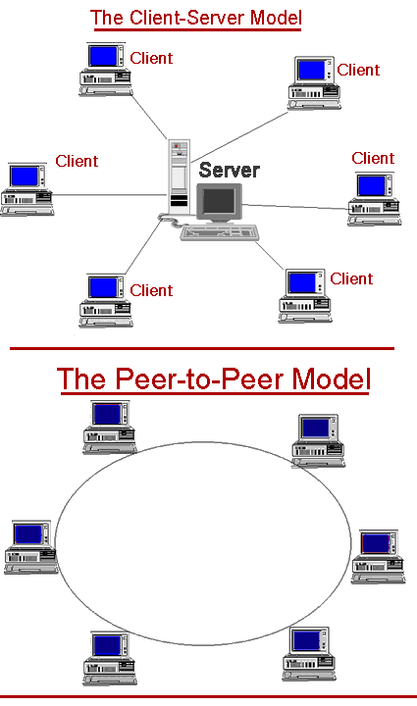

**Network can be divided in to two main categories:**

* Peer-to-peer.
* Server – based.

**Network Architectures:**

**Ethernet**

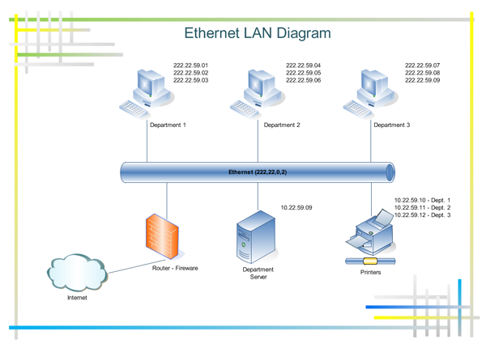

Ethernet is the most popular physical layer LAN technology in use today. Other LAN types include Token Ring, Fast Ethernet, Fiber Distributed Data Interface (FDDI), Asynchronous Transfer Mode (ATM) and LocalTalk. Ethernet is popular because it strikes a good balance between speed, cost and ease of installation. These benefits, combined with wide acceptance in the computer marketplace and the ability to support virtually all popular network protocols, make Ethernet an ideal networking technology for most computer users today. The Institute for Electrical and Electronic Engineers (IEEE) defines the Ethernet standard as IEEE Standard 802.3. This standard defines rules for configuring an Ethernet network as well as specifying how elements in an Ethernet network interact with one another. By adhering to the IEEE standard, network equipment and network protocols can communicate efficiently.

**Token Ring**

Token Ring is another form of network configuration which differs from Ethernet in that all messages are transferred in a unidirectional manner along the ring at all times. Data is transmitted in tokens, which are passed along the ring and viewed by each device. When a device sees a message addressed to it, that device copies the message and then marks that message as being read. As the message makes its way along the ring, it eventually gets back to the sender who now notes that the message was received by the intended device. The sender can then remove the message and free that token for use by others.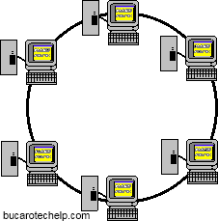

Various PC vendors have been proponents of Token Ring networks at different times and thus these types of networks have been implemented in many organizations.

**FDDI**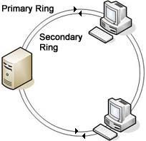

FDDI (Fiber-Distributed Data Interface) is a standard for data transmission on fiber optic lines in a local area network that can extend in range up to 200 km (124 miles). The FDDI protocol is based on the token ring protocol. In addition to being large geographically, an FDDI local area network can support thousands of users.

**Network Cables and Stuff:**

In the network you will commonly find three types of cables used these are the, coaxial cable, fiber optic and twisted pair.

**Thick Coaxial Cable**

This type cable is usually yellow in color and used in what is called thicknets, and has two conductors. This coax can be used in 500-meter lengths. The cable itself is made up of a solid center wire with a braided metal shield and plastic sheathing protecting the rest of the wire.

**Thin Coaxial Cable**

As with the thick coaxial cable is used in thicknets the thin version is used in thinnets. This type cable is also used called or referred to as RG-58. The cable is really just a cheaper version of the thick cable.

**Fiber Optic Cable**

As we all know fiber optics are pretty darn cool and not cheap. This cable is smaller and can carry a vast amount of information fast and over long distances.

**Twisted Pair Cables**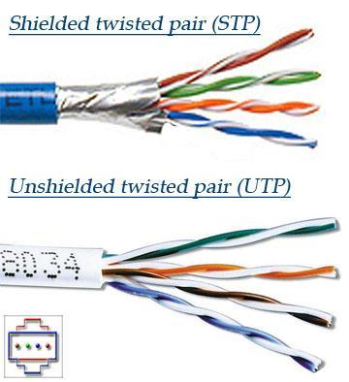

These come in two flavors of unshielded and shielded.

**Shielded Twisted Pair (STP)**

Is more common in high-speed networks. The biggest difference you will see in the UTP and STP is that the STP use's metallic shield wrapping to protect the wire from interference.

Something else to note about these cables is that they are defined in numbers also. The bigger the number the better the protection from interference. Most networks should go with no less than a CAT 3 and CAT 5 is most recommended. Now you know about cables we need to know about connectors. This is pretty important and you will most likely need the RJ-45 connector. This is the like the phone jack connector and looks similar with the exception that the RJ-45 is bigger. Most commonly your connector are in two flavors and this is BNC (Bayonet Naur Connector) used in thicknets and the RJ-45 used in smaller networks using UTP/STP.

**Unshielded Twisted Pair (UTP)**

This is the most popular form of cables in the network and the cheapest form that you can go with. The UTP has four pairs of wires and all inside plastic sheathing. The biggest reason that we call it Twisted Pair is to protect the wires from interference from themselves. Each wire is only protected with a thin plastic sheath.

**Network Topologies:**

**What is a Network topology?**

A network topology is the geometric arrangement of nodes and cable links in a LAN,

There are three topology's to think about when you get into networks. These are the star, rind, and the bus.

**Star**, in a star topology each node has a dedicated set of wires connecting it to a central network hub. Since all traffic passes through the hub, the hub becomes a central point for isolating network problems and gathering network statistics.

**Ring**, a ring topology features a logically closed loop. Data packets travel in a single direction around the ring from one network device to the next. Each network device acts as a repeater, meaning it regenerates the signal.

**Bus**, the bus topology, each node (computer, server, peripheral etc.) attaches directly to a common cable. This topology most often serves as the backbone for a network. In some instances, such as in classrooms or labs, a bus will connect small workgroups

**Mesh:**

**Tree:**

**Hybrid:**

**Network Components:**

1. **Network Interface Cards:**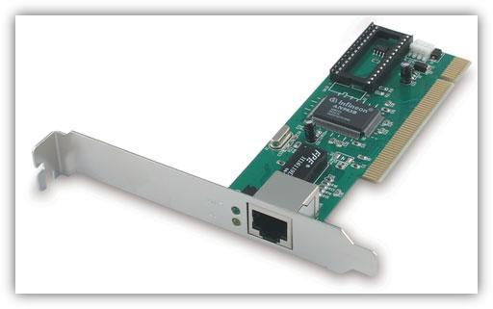

Network interface cards, commonly referred to as NICs, and are used to connect a PC to a network. The NIC provides a physical connection between the networking cable and the computer's internal bus. Different computers have different bus architectures; PCI bus master slots are most commonly found on 486/Pentium PCs and ISA expansion slots are commonly found on 386 and older PCs. NICs come in three basic varieties: 8-bit, 16-bit, and 32-bit. The larger the number of bits that can be transferred to the NIC, the faster the NIC can transfer data to the network cable.

Many NIC adapters comply with Plug-n-Play specifications. On these systems, NICs are automatically configured without user intervention, while on non-Plug-n-Play systems, configuration is done manually through a setup program and/or DIP switches.

Cards are available to support almost all networking standards, including the latest Fast Ethernet environment. Fast Ethernet NICs are often 10/100 capable, and will automatically set to the appropriate speed. Full duplex networking is another option, where a dedicated connection to a switch allows a NIC to operate at twice the speed.

1. **Hubs/Repeaters:**

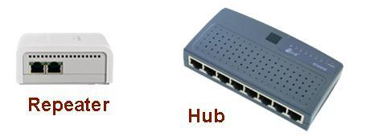

**1. Repeater** – A repeater operates at the physical layer. Its job is to regenerate the signal over the same network before the signal becomes too weak or corrupted so as to extend the length to which the signal can be transmitted over the same network. An important point to be noted about repeaters is that they do not amplify the signal. When the signal becomes weak, they copy the signal bit by bit and regenerate it at the original strength. It is a 2 port device.

**2. Hub** –  A hub is basically a multiport repeater. A hub connects multiple wires coming from different branches, for example, the connector in star topology which connects different stations. Hubs cannot filter data, so data packets are sent to all connected devices.  In other words, collision domain of all hosts connected through Hub remains one.  Also, they do not have intelligence to find out best path for data packets which leads to inefficiencies and wastage.

1. **Bridges:**

A bridge operates at data link layer. A bridge is a repeater, with add on the functionality of filtering content by reading the MAC addresses of source and destination. It is also used for interconnecting two LANs working on the same protocol. It has a single input and single output port, thus making it a 2 port device.

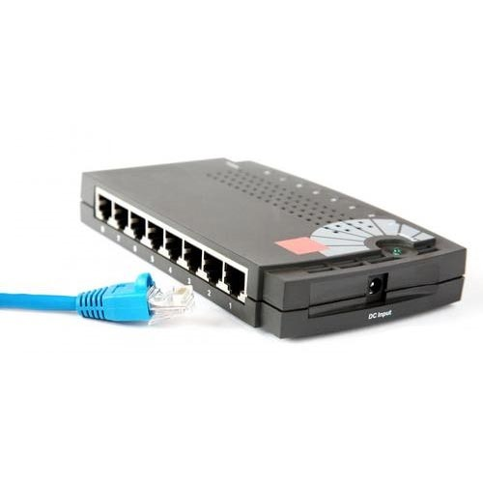

1. **Ethernet Switches:**Ethernet Switches

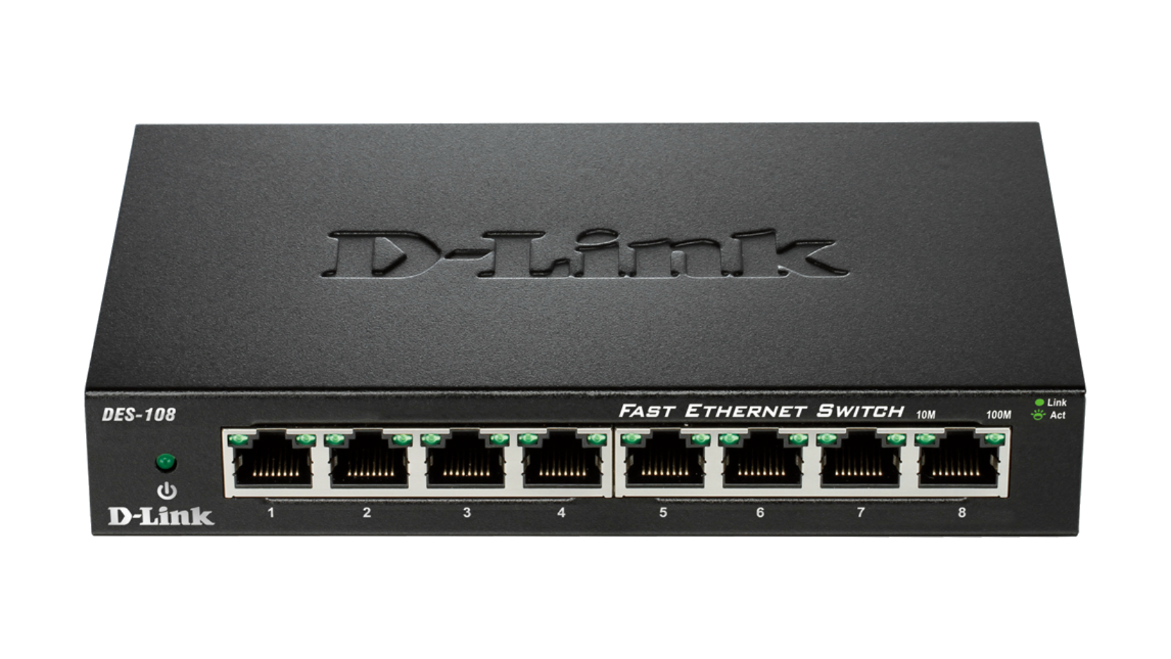

A switch is a multiport bridge with a buffer and a design that can boost its efficiency (a large number of ports imply less traffic) and performance. A switch is a data link layer device. The switch can perform error checking before forwarding data, that makes it very efficient as it does not forward packets that have errors and forward good packets selectively to correct port only.  In other words, switch divides collision domain of hosts, but broadcast domain remains same.

1. [**Routers**](https://www.geeksforgeeks.org/network-devices-hub-repeater-bridge-switch-router-gateways/#Routers)

A router is a device like a switch that routes data packets based on their IP addresses. Router is mainly a Network Layer device. Routers normally connect LANs and WANs together and have a dynamically updating routing table based on which they make decisions on routing the data packets. Router divide broadcast domains of hosts connected through it.

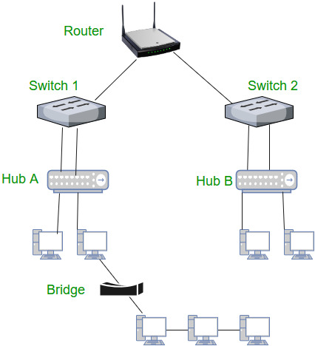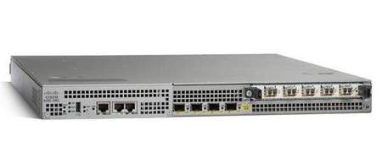

1. **Gateway**

A gateway, as the name suggests, is a passage to connect two networks together that may work upon different networking models/different base protocols. A network gateway can be implemented completely in software, hardware, or a combination of both, depending on the types of protocols they support.

They basically work as the messenger agents that take data from one system, interpret it, and transfer it to another system. Gateways are also called protocol converters and can operate at all the layer. Gateways are generally more complex than switch or router. A gateway is a router or proxy server that routes between networks. It belongs to the same subnet to which the PC belongs.

**Conclusion:**

We studied the network topologies and components in this assignment.

**Post Lab Questions:**

1. Compare in tabular format: Hub, Switch, Bridge Router.
2. Names of at least five companies who design and manufacture the switches and routers.
3. Add a two-page summary of your own study of this lab assignment.